**Global Estimates of Maternal Bereavement:**

**New Indicators of the Cumulative Prevalence of Child Loss in 168 Countries and Territories**

**Abstract**

**Background**

Social epidemiology demonstrates the health consequences of parental bereavement; yet we lack standard, country-level estimates of the prevalence of bereaved parents worldwide. We estimate the prevalence of bereaved mothers in 168 countries and territories.

**Methods**

We generate indicators of the cumulative prevalence of mothers who have had an infant, under-five-year-old, or any-age child ever die by using publicly available survey data, and a novel, indirect approach that combines formal kinship models and life table methods. We label these measures the maternal cumulative prevalence of infant mortality (mIM), under-five mortality (mU5M), and offspring mortality (mOM).

**Results**

In several Asian and European countries, the mIM and mU5M are below 10 per 1,000 mothers. Conversely, several Middle Eastern and African countries have mIM and mU5M values exceeding 200 per 1,000 mothers. Inequality in mothers’ experience of child loss is enormous: mothers in some African countries are more than 100 times more likely to have had a child die than mothers in some Asian and European countries. In more than 20 African countries, the mOM exceeds 500 per 1,000 mothers, meaning it is more common for a surviving mother to be bereaved than not.

**Conclusion**

Our study shows that the relationship between a country’s annualized infant and under-five mortality rates and parents’ cumulative experience of child death is not readily apparent, confirming we must directly measure parental bereavement. Our study reveals enormous global disparities in mothers’ experience of child loss, and in turn, the downstream mental and physical health risks associated with bereavement.

**Key Messages**

* Social epidemiology acknowledges the health significance of parental bereavement, yet we lack estimates of its global prevalence.
* We use survey data and indirect methods to generate three country-level bereavement indicators: the maternal cumulative prevalence of infant mortality (mIM), under-five mortality (mU5M), and offspring mortality (mOM).

Mothers in select Middle Eastern and African countries are more than 100 times more likely to have experienced an infant or under-five child die than mothers in some Asian and European countries. While in many Asian and European countries the mOM is lower than 30 per 1,000 mothers, in numerous African countries the mOM exceeds 500 per 1,000 older mothers.

* Studying maternal bereavement reveals how epidemiological disparities accumulate in mothers’ lives to generate tremendous reproductive inequality.

Infant and child mortality rates have declined steadily worldwide over the last fifty years1. Even with short periods of stagnant improvement, and persistent between- and within-country inequality, the global trends represent good news for children and their parents. Yet how improvements in annualized rates of infant and child mortality reflect in parents’ cumulative experience of child loss is unknown. A child’s death has grave consequences for parents, but country-level estimates of the prevalence of bereaved parents are available only for select sub-Saharan African countries. Recent research shows that in multiple sub-Saharan African countries as recently as 2015, upwards of one-third of younger mothers (ages 20-44) and one-half of mothers age 45-49 years old having had at least one child die.3

Whether such high levels of maternal bereavement characterize other low- and middle-income countries, and how they compare to levels in high-income countries, remain unknown. In this article, we offer the first country-level estimates of the prevalence of bereaved mothers in 168 countries and territories. We generate three indicators of the cumulative prevalence of mothers who have had an infant, under-five year old, or any-age child ever die. We label these country-level indicators: the maternal cumulative prevalence of infant mortality (mIM), under-five mortality (mU5M), and offspring mortality (mOM).3 We calculate these three measures separately for two groups of mothers: those in the peak of their reproductive years (ages 20-44) and those who have recently completed, or are soon to complete, childbearing (ages 45-49). We generate these indicators using survey data for 89 countries and, to achieve global coverage, in 79 countries we supplement these estimates with an indirect estimation strategy that applies insights from formal demography by combining information from life tables and age-specific fertility schedules.4

Generating country-level indicators of maternal bereavement offers two contributions. First, this exercise clarifies that the relationship between a country’s annualized infant and under-five mortality rates, which are contemporaneous, and parents’ experiences of child death, which are cumulative, is not readily apparent. Instead, the prevalence of bereaved parents is a unique aspect of a country’s epidemiological profile. This is because, aside from mortality conditions, a country’s fertility level determines how many years an average mother has a child at risk of the annualized rates of infant and child mortality, and thus influences her cumulative risk of ever experiencing a child die. Moreover, the degree to which child deaths are dispersed across a population in a country, versus concentrated among a small, disadvantaged subgroup of mothers, determines if child mortality affects a smaller fraction of parents repeatedly, or if it is a more prevalent experience. Finally, the legacy of higher child mortality years earlier, when older mothers had their first child, can also linger in a population, contributing to higher cumulative estimates of maternal bereavement than the recent epidemiological reality implies. Moreover, adult mortality conditions dictate how many bereaved mothers survive to share their experience versus how many also die prematurely, thereby erasing their account of child loss. The confounding influence of these population dynamics and epidemiological conditions mandate that we explicitly estimate the prevalence of bereaved mothers.

In revealing that the prevalence of bereaved mothers is a distinct feature of a country’s reproductive health profile, the study’s second contribution is to draw attention to how infant, child, and adolescent mortality conditions can give rise to a large population of grieving parents—parents deserving of public health attention. Cross-country inequalities in the burden of family bereavement and kin loss not only reflect disparate health environments, but also inequality in the risk of poor health outcomes associated with bereavement.3,5–9 A child’s death has profound and lasting influence on parents’ wellbeing, including their mental health10,11 and physical health and longevity.12,13 A child’s death bears heavy on mothers, in particular, and the adverse effects of their grief can persist for years—even decades.10,12,14 Even as infant and child mortality conditions hint to large between-country inequality in the burden of parental bereavement, the magnitude and distribution of the disparities are unknown. By demonstrating the size and distribution of inequalities in the burden of child loss, this study reveals how epidemiological disparities accumulate in mothers’ lives to generate tremendous reproductive inequality.

**METHODS**

We first generate indicators of the maternal cumulative prevalence of child death directly using data from nationally representative surveys that feature women’s reproductive histories. Our direct estimation strategy makes use of three data sources. For the United States, we make use of the National Survey of Family Growth (NSFG) (2013-17). NSFG collects reproductive history calendars from women ages 15-44 years old.[1] For 56 countries across Africa, Asia, Europe, Latin America and the Caribbean, and Oceania, we leverage data from the Demographic and Health Surveys (DHS) program. DHS data come from nationally representative household surveys that collect detailed information from various household members, including women ages 15-49, and were collected between 2010 and 2018.[2] Finally, for 32 additional countries in Africa, Asia, Europe, and Latin America and the Caribbean that lack recent DHS data, we make use of Multiple Indicator Cluster Surveys (MICS), which come from nationally representative household surveys collected between 2010-2018.[3] SI Table 1 in the supplemental file provides the full list of countries, data sources, survey years, and analytic sample sizes.

In each survey, we restrict the analytic samples to women who have had at least one live birth (i.e., the women are at risk of child loss), and use information from women’s reproductive histories, including the vital status of each child and, for those deceased, the age at death, we calculate the mIM, mU5M, and mOM.[4] To estimate the mIM, we tabulate the prevalence of mothers who have ever experienced the death of at least one infant. We sum the number of mothers who had a child die before age 1 among those who ever had a live birth and express this per 1,000 mothers. To estimate the mU5M, we make the same calculation, but sum mothers who have ever had a child die before reaching age 5. The mOM indexes the prevalence of mothers who have experienced a child death, regardless of that child’s age.[5] Due to censoring, we calculate the mOM for 45- to 49-year-old mothers only.

To expand our perspective beyond our survey coverage, we introduce a novel, formal demographic approach to indirectly estimate the prevalence of bereaved mothers in 79 additional countries. Not all countries feature recent, nationally-representative surveys with reproductive information from women; thus, this approach allows us to estimate the prevalence of bereaved mothers by drawing on publicly-available demographic data from the United Nations World Population Prospects.[6] Our indirect kin-cohort method is an extension to the Goodman-Keyfitz-Pullum kinship equations.15 Our analytical approach combines formal kinship relationships from mathematical demography with life table methods.

The kin-cohort method proceeds in three steps. First, we use kinship equations to determine the age-specific probability that an average woman will experience the death of an infant, child, or offspring deaths. With these probabilities, we construct life tables to estimate the fraction of women aged a in cohort c who ever experienced the death of a child (accounting for the mortality of women). With this, we then solve for the proportion of women (per 1,000 mothers) who have ever lost a child. Second, we use a different set of life-table equations to estimate the proportion of mothers, rather than all women, who have experienced the death of an offspring. We consider fertility as a “hazard rate” to approximate the number of women that have had at least one child at specific ages after experiencing a set of age-specific fertility rates. We then define, for a given cohort, the proportion of mothers (per 1,000 mothers) who have ever lost a child of a specific age. Third, we convert our cohort estimate to period estimates so that they are interpreted exactly as the direct survey estimates and refer to a child’s death before age one (mIM), age five (mU5M), or any age (mOM). Note that for countries with no survey estimates, we use data from 2016—the modal year of survey coverage for our data. For countries with survey data available, however, we generate our indirect estimates with UNWPP data from the same year the survey was collected to ensure comparability.

In the main findings, we prioritize the survey estimates and present the indirectly generated estimates only for countries where survey-based ones are unavailable. However, in SI Fig. 1 of the online supplement, we generated indirect estimates for the 89 countries for which we also have survey data to demonstrate the comparability of the estimates. In line with past evidence of the accuracy of this approach to estimating maternal bereavement4, SI Fig. 1 in the online supplement shows the high correlations between the indirectly generated mIM, mU5M, and mOM and the direct survey estimates for the 89 countries. In general, the indirect approach tends to yield slightly higher estimates of bereavement than the direct approach; this discrepancy may be driven by the fact that the indirect approach cannot address the clustering of deaths to specific mothers, which the survey-generated estimates do. Notably, however, clustering of child deaths is most common in Africa, where mortality and fertility are exceptionally high, and where we have almost full survey coverage. Of course, the indirect estimates could also be higher in these countries due to the underestimation of child loss in the survey data. Even though the survey estimates are derived from nationally representative samples, mothers may underreport on the deaths of children. Moreover, some hard to reach, populations—including those affected by war or conflict and thus who are more likely to have higher levels of child loss—can be underrepresented in national surveys.

**RESULTS**

**Maternal Burden of Infant Mortality**

**Fig. 1** maps the mIM, offering a worldwide portrait of the prevalence of mothers (ages 20-44 years old) who have experienced an infant death. In select Asian and European countries, fewer than 5 per 1,000 of mothers 20-44 and 20 per 1,000 mothers 45-49 have ever lost an infant (Hong Kong, Singapore, Iceland, Japan, Finland, Sweden, Slovenia, Spain, Republic of Korea, Czech Republic, Italy, Norway, Portugal). The mIM is slightly higher in select high-income contexts, including the United States: NSFG survey estimates 7.2 per 1,000 in US have lost a child (the kin-cohort approach estimates 12.1 per 1,000, a difference of 0.5 percentage points).

In more than 30 countries, the mIM exceeds 150 per 1,000 mothers ages 20-44 years old. In 16 countries in the Middle East and sub-Saharan Africa, more than 200 per 1,000 younger mothers have lost an infant (Afghanistan, Burkina Faso, Central African Republic, Chad, Democratic Republic of the Congo, Ethiopia, Equatorial Guinea, Guinea, Liberia, Niger, Nigeria, Guinea-Bissau, Mozambique, Sierra Leone, Somalia, South Sudan). That 20% of younger mothers have lost an infant is jarring.

The mIM also offers a new scale of the inequality in maternal experiences that women in different countries have endured and shows this inequality to be far vaster than annualized, child-centered mortality metrics might imply. Overall, the global range of mIM values for mothers ages 20-44 stretches from the low of 2.2 per 1,000 mothers in Hong Kong to 303.3 per 1,000 mothers in Sierra Leone. This means that, in Sierra Leone, young mothers are 138 times more likely to have experienced a child die than mothers in the Hong Kong. This enormous difference far exceeds the still large discrepancy in the countries’ infant mortality rates: infants born in Sierra Leone are 67 times more likely to die than those born in Hong Kong (95.5 versus 1.4 infant deaths per 1,000 live births).

**Fig. 2** presents the mIM estimates for older mothers. Overall, the mIM values for older mothers are higher, with the average of 145 mothers per 1,000 having lost an infant across the 168 countries and territories. However, again, the global spread of mIM values is striking. In multiple countries, fewer than 10 per 1,000 of mothers have lost an infant (Hong Kong, Japan, Singapore, Finland, Sweden, Iceland, Spain). In more than 50 countries across the Middle East and sub-Saharan Africa, however, over 200 per 1,000 mothers ages 45-49 have lost an infant. Liberia has the highest mIM for older mothers, with an estimated 465.3 per 1,000 mothers having lost an infant: older mother in Liberia is 78 times more likely to have experienced an infant die than an older mother in Hong Kong, the country with the lowest recorded mIM for older mothers (6.0 per 1,000). Despite staggering inequality, global inequality in infant loss for older mothers is smaller than that for younger mothers, possibly owing to the legacy of higher mortality worldwide, or because bereaved mothers in the highest mortality contexts having also died prematurely, resulting in their erasure from the estimates of bereavement.

**Maternal Burden of Under-Five Mortality (mU5M)**

**Fig. 3** maps the mU5M, summarizing the prevalence of mothers (ages 20-44 years old) who have experienced a child die between birth and age five. In select countries, fewer than 5 per 1,000 young mothers have experienced a child die before age five (Hong Kong, Singapore, Iceland, Japan, Finland, Sweden, Slovenia, Spain). In select higher-income countries, like the United States, upwards of 10 per 1,000 mothers age 20-44 have lost a child. In more than a dozen countries across the Middle East and West and Central Africa, however, more than 300 per 1,000 mothers have lost a child (Afghanistan, Cameroon, Guinea-Bissau, Liberia, South Sudan, Equatorial Guinea, Nigeria, Guinea, Burkina Faso, Central African Republic, Sierra Leone, Chad, Somalia, Niger). The mU5M ranges from a low of 3.2 per 1,000 mothers ages 20-44 (Hong Kong) to 437.2 per 1,000 mothers (Niger). As with the mIM, the inequality in mothers’ experiences of under-five mortality far exceeds both current and historical differences in the under-five mortality rates themselves. The mU5M in Niger is 137 times that of Hong Kong, even as the under-five mortality rate in the former is only 49 times higher than the latter (2.2 child deaths per 1,000 in Hong Kong versus 108.7 child deaths per 1,000 in Niger).

As expected, **Fig. 4** shows that mU5M levels are higher among older mothers, who not only entered motherhood during higher mortality conditions, but also have been mothers for several years to often multiple children, and thus have had far greater exposure to the risk of child loss. In the countries with the lowest mU5M estimates, fewer than 30 per 1,000 mothers have ever lost a child, with some countries (Hong Kong, Singapore, and Japan) with estimates fewer than 10 per 1,000 mothers. Yet nearly 50 countries have levels of maternal loss of young children that are *ten times* higher than these countries—settings where nearly one-third of older mothers have experienced a young child die. In total, the estimates range from a low of from 8.2 mothers per 1,000 (Hong Kong) to 705.7 mothers per 1,000 (Niger): in Niger, a mother ages 45-49 is more than 86 times likely to have lost a young child than a mother in Hong Kong.

Additional comparisons of the mIM and mU5M versus the infant and under-five mortality rates (also shown in SI Table 1) further demonstrates how this explicitly maternal perspective reveals global patterns of bereavement that cannot be inferred from our conventional mortality indicators. Among the 20 countries with the lowest infant or child mortality rates, nine of these countries do *not* feature among the 20 countries with the lowest mIMs and mU5Ms. Similarly, 10 of the top 20 countries with the highest mIMs and mU5Ms do not feature the highest infant and under-five mortality rates. These comparisons confirm that an explicitly maternal perspective is appropriate to avoid overlooking countries with a higher than realized maternal burden of child loss.

**Maternal Burden of Offspring Mortality (mOM)**

Despite the global emphasis on measuring and monitoring mortality before age five, parents’ risk of losing a child persists beyond the child’s fifth birthday. To understand the total burden of child loss, regardless of the child’s age at the time of death, **Fig. 5** depicts the mOM, capturing the burden of all offspring mortality among mothers 45-49 years old. As expected, the global patterning of the mOM indicators closely aligns with that of the mIM and mU5M: countries where many surviving mothers have had an infant or under-five year old die are also those where mothers have lost adolescent and young adult children. The reigning pattern across high-income countries is that fewer than 30 per 1,000 mothers have ever lost a child. Even as 30 countries have mOM values reflecting that fewer than 3% of mothers have ever lost a child, in more than 50 countries, the mOM levels are 10 times higher: across countries in Africa, Latin America, the Middle East, and Southeast Asia, more than 30% of mothers have ever lost a child. In as many 22 countries—all located in sub-Saharan Africa—more than 50% of older mothers have experienced the death of a child. This is striking: in these countries it is more common for a surviving mother to be bereaved than not. The highest mOM documented in Niger (792.6 per 1,000 mothers) is 73 times higher than the lowest mOM value in Hong Kong (10.8 per 1,000 mothers).

**DISCUSSION**

We formalized an accurate and systematic way to measure maternal bereavement that reveals enormous disparities in the burden of child loss across the globe—disparities that cannot be gleaned from child-centered measures of mortality. Even as infant and mortality conditions improve worldwide, in several cases, mothers in low- and middle-income countries are more than 10 times as likely to have had a child die than those in select in high-income countries; in several sub-Saharan African countries, mothers countries are more than 100 times more likely to have experienced a child die than mothers who inhabit the low-mortality enclaves of our world.

Overlaying these findings with the shear absence of research on parental bereavement in low-income countries highlights yet another a meta-inequality that cuts across the trends and patterns that we have established here: that the world regions in which child loss is concentrated are the ones where fewer empirical studies have quantified and studied the consequences of this experience. Future efforts to acknowledge the bereavement burden as another indicator of global inequality—one that offers a unique view of how epidemiological inequality accumulate to produce enormous disparities in women’s maternal experiences—will spur additional understanding of its implications for additional dimensions of population health.

**REFERENCES**

1. Wang, H. *et al.* Global, regional, and national levels of neonatal, infant, and under-5 mortality during 1990–2013: a systematic analysis for the Global Burden of Disease Study 2013. *The Lancet* **384**, 957–979 (2014).

2. Ely, D. M. & Driscoll, A. K. Infant mortality in the United States, 2017: Data from the period linked birth/infant death file. (2019).

3. Smith-Greenaway, E. & Trinitapoli, J. Maternal cumulative prevalence measures of child mortality show heavy burden in sub-Saharan Africa. *Proceedings of the National Academy of Sciences* **117**, 4027–4033 (2020).

4. Alburez-Gutierrez, D., Kolk, M. & Zagheni, E. Women’s experience of child death over the life course: A global demographic perspective. (2019).

5. Fletcher, J., Mailick, M., Song, J. & Wolfe, B. A sibling death in the family: Common and consequential. *Demography* **50**, 803–826 (2013).

6. Thomas, K. J. Child deaths in the past, their consequences in the present, and mortality conditions in sub-Saharan Africa. *Proceedings of the National Academy of Sciences* **117**, 4453–4455 (2020).

7. Umberson, D. *et al.* Death of family members as an overlooked source of racial disadvantage in the United States. *Proceedings of the National Academy of Sciences* **114**, 915–920 (2017).

8. Verdery, A. M., Smith-Greenaway, E., Margolis, R. & Daw, J. Tracking the reach of COVID-19 kin loss with a bereavement multiplier applied to the United States. *Proceedings of the National Academy of Sciences* **117**, 17695–17701 (2020).

9. Verdery, A. M. & Margolis, R. Projections of white and black older adults without living kin in the United States, 2015 to 2060. *Proceedings of the National Academy of Sciences* **114**, 11109–11114 (2017).

10. Rogers, C. H., Floyd, F. J., Seltzer, M. M., Greenberg, J. & Hong, J. Long-term effects of the death of a child on parents’ adjustment in midlife. *Journal of family psychology* **22**, 203 (2008).

11. Song, J., Floyd, F. J., Seltzer, M. M., Greenberg, J. S. & Hong, J. Long‐Term Effects of Child Death on Parents’ Health‐Related Quality of Life: A Dyadic Analysis. *Family relations* **59**, 269–282 (2010).

12. Li, J., Precht, D. H., Mortensen, P. B. & Olsen, J. Mortality in parents after death of a child in Denmark: a nationwide follow-up study. *The lancet* **361**, 363–367 (2003).

13. Rostila, M., Saarela, J. & Kawachi, I. The forgotten griever: a nationwide follow-up study of mortality subsequent to the death of a sibling. *American journal of epidemiology* **176**, 338–346 (2012).

14. Li, J., Laursen, T. M., Precht, D. H., Olsen, J. & Mortensen, P. B. Hospitalization for mental illness among parents after the death of a child. *New England Journal of Medicine* **352**, 1190–1196 (2005).

15. Keyfitz, N. *Applied mathematical demography*. (Springer, 1985).

16. Preston, S. H., Heuveline, P. & Guillot, M. *Demography: measuring and modeling population processes*. (Blackwell Publishers, 2001).

17. Wachter, K. W. *Essential demographic methods*. (Harvard Univ. Press, 2014).

18. Wilson, C. On the scale of global demographic convergence 1950–2000. *Population and Development Review* **27**, 155–171 (2001).

Fig. 1. Maternal Infant Mortality (mIM) Indicators for mothers 20-44-years-old

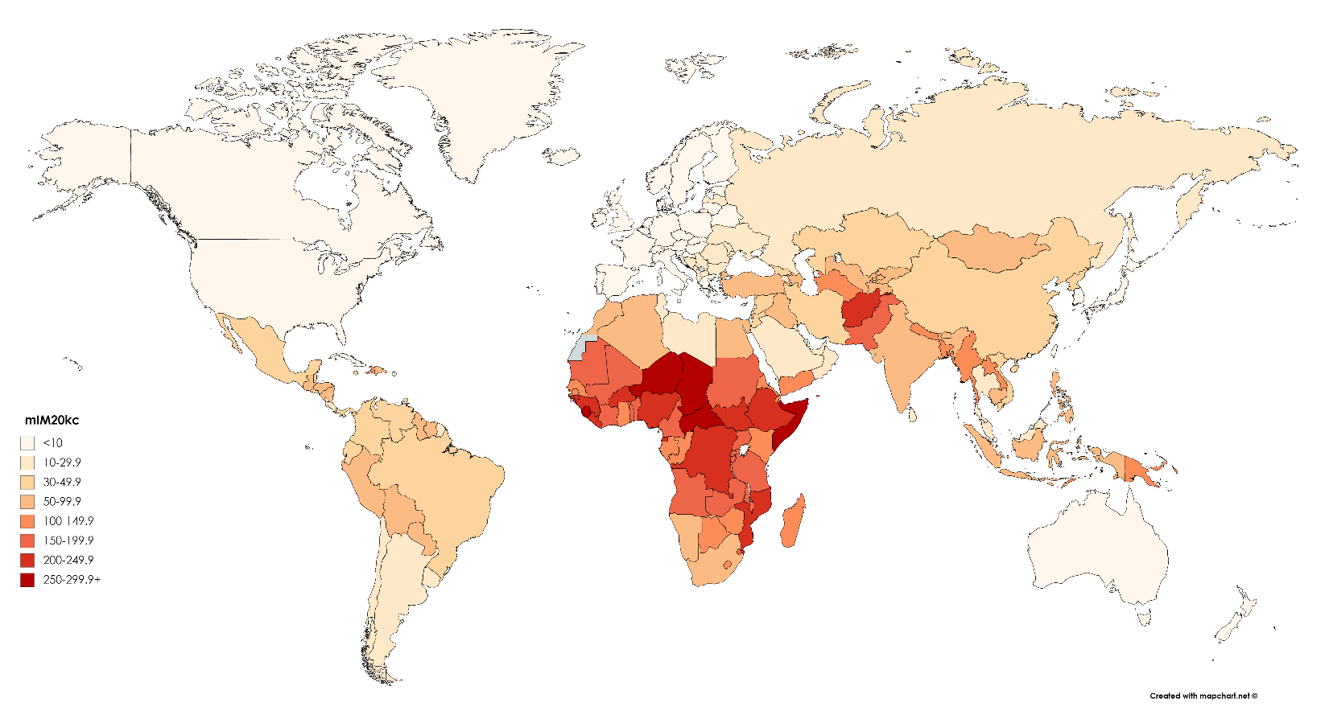

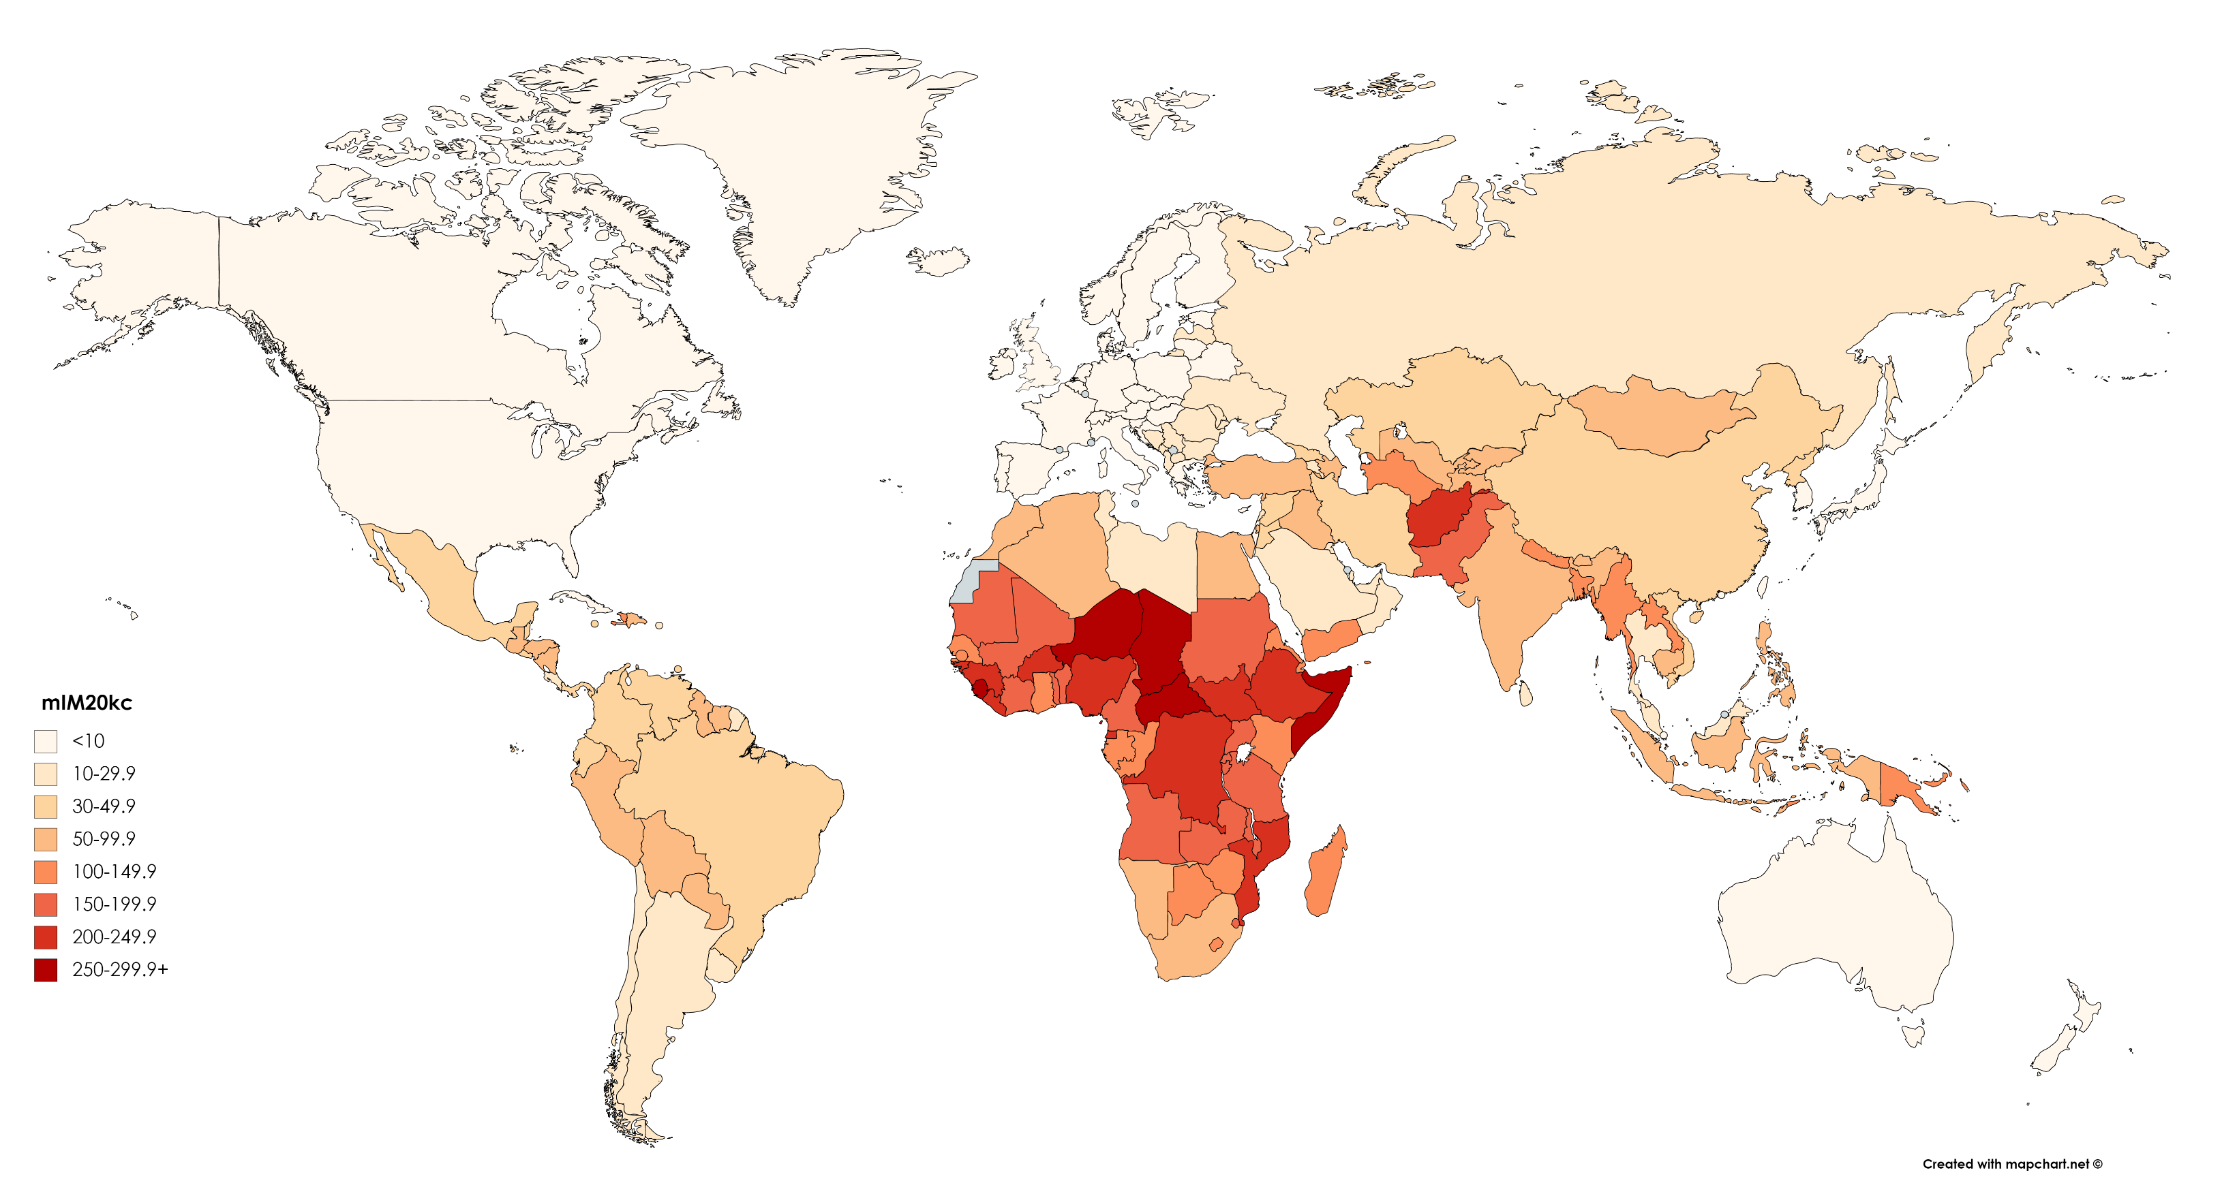

Note: see SI Table 1 for list of estimates and data sources

Fig. 2. Maternal Infant Mortality (mIM) Indicators for mothers 45-49-years-old

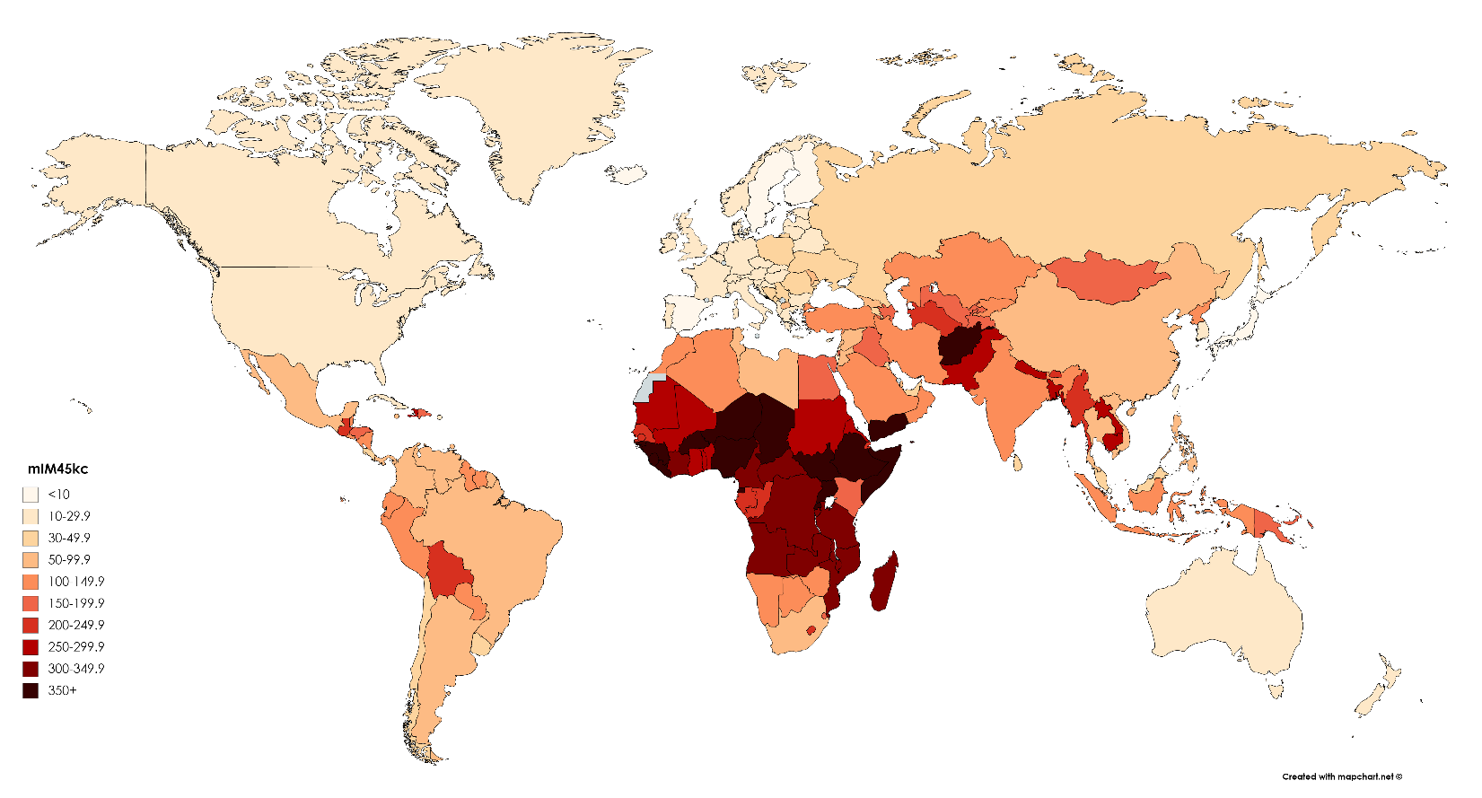

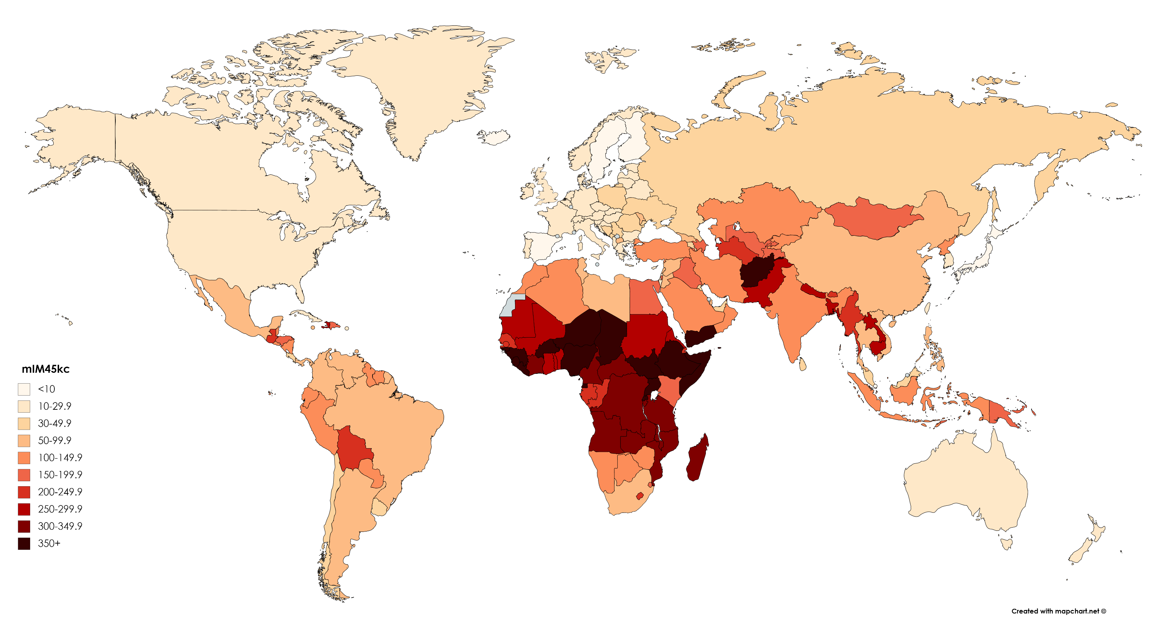

Note: see SI Table 1 for list of estimates and data sources

Fig. 3. Maternal Under-Five Mortality (mIM) Indicators for mothers ages 20-44-years-old

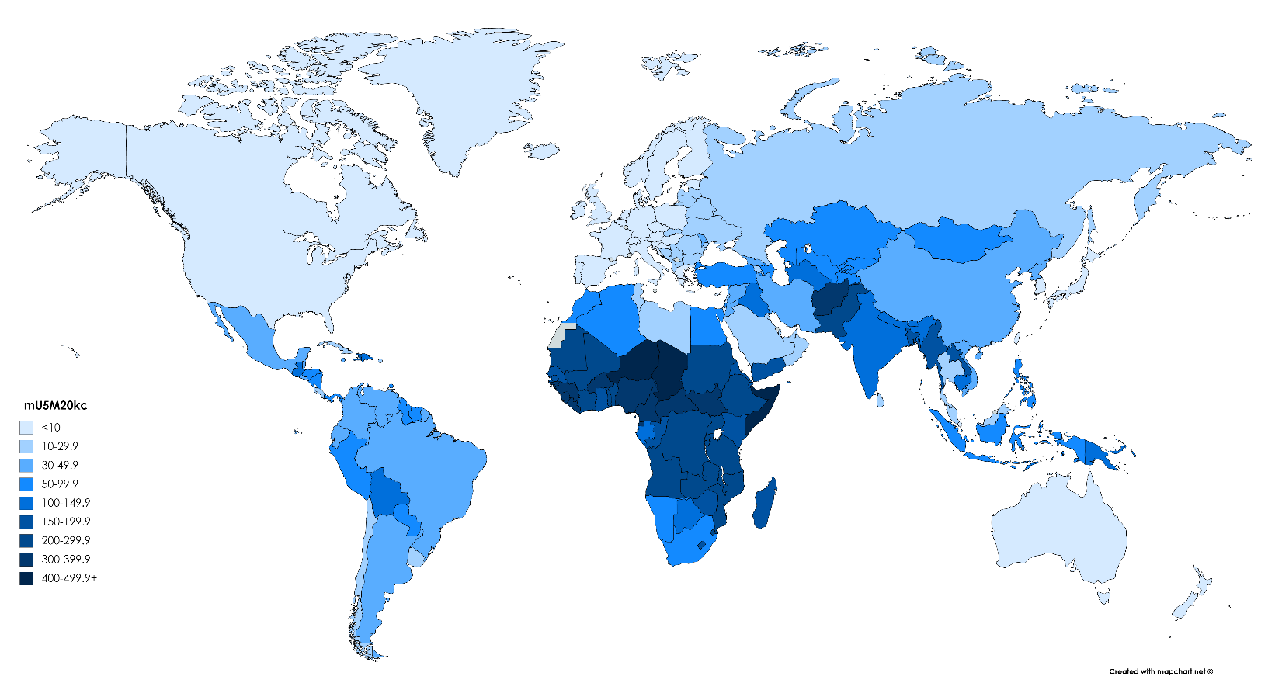

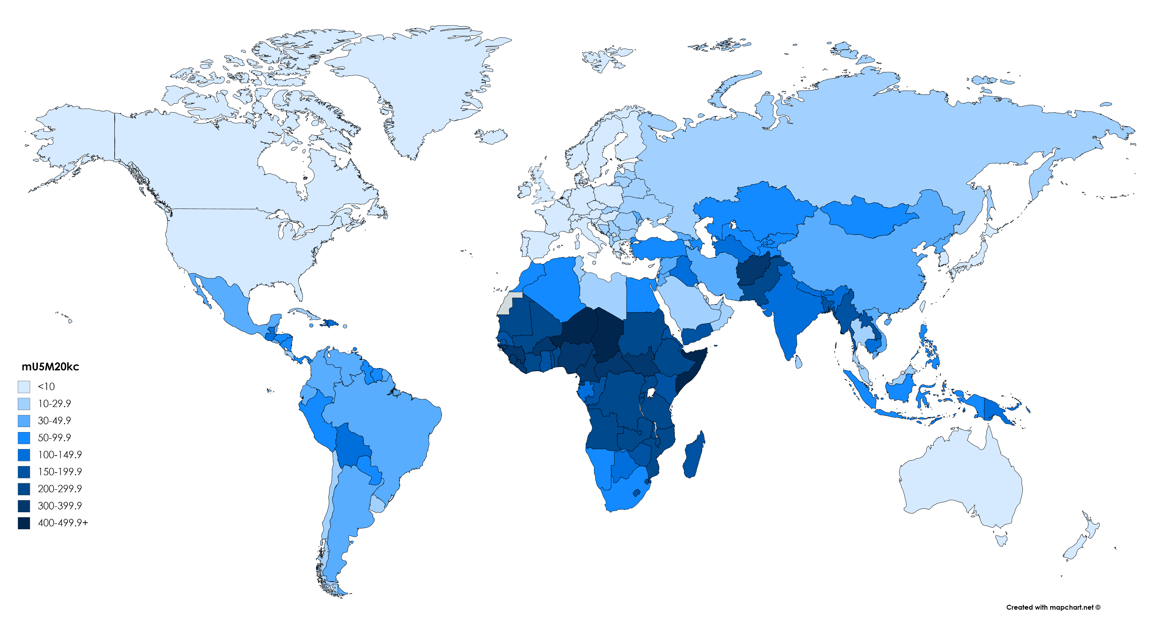

Note: see SI Table 1 for list of estimates and data sources

Fig. 4. Maternal Under-Five Mortality (mIM) Indicators for mothers ages 45-49-years-old

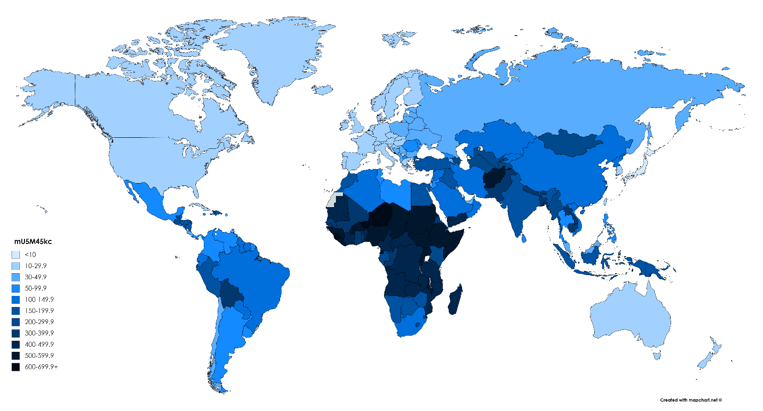

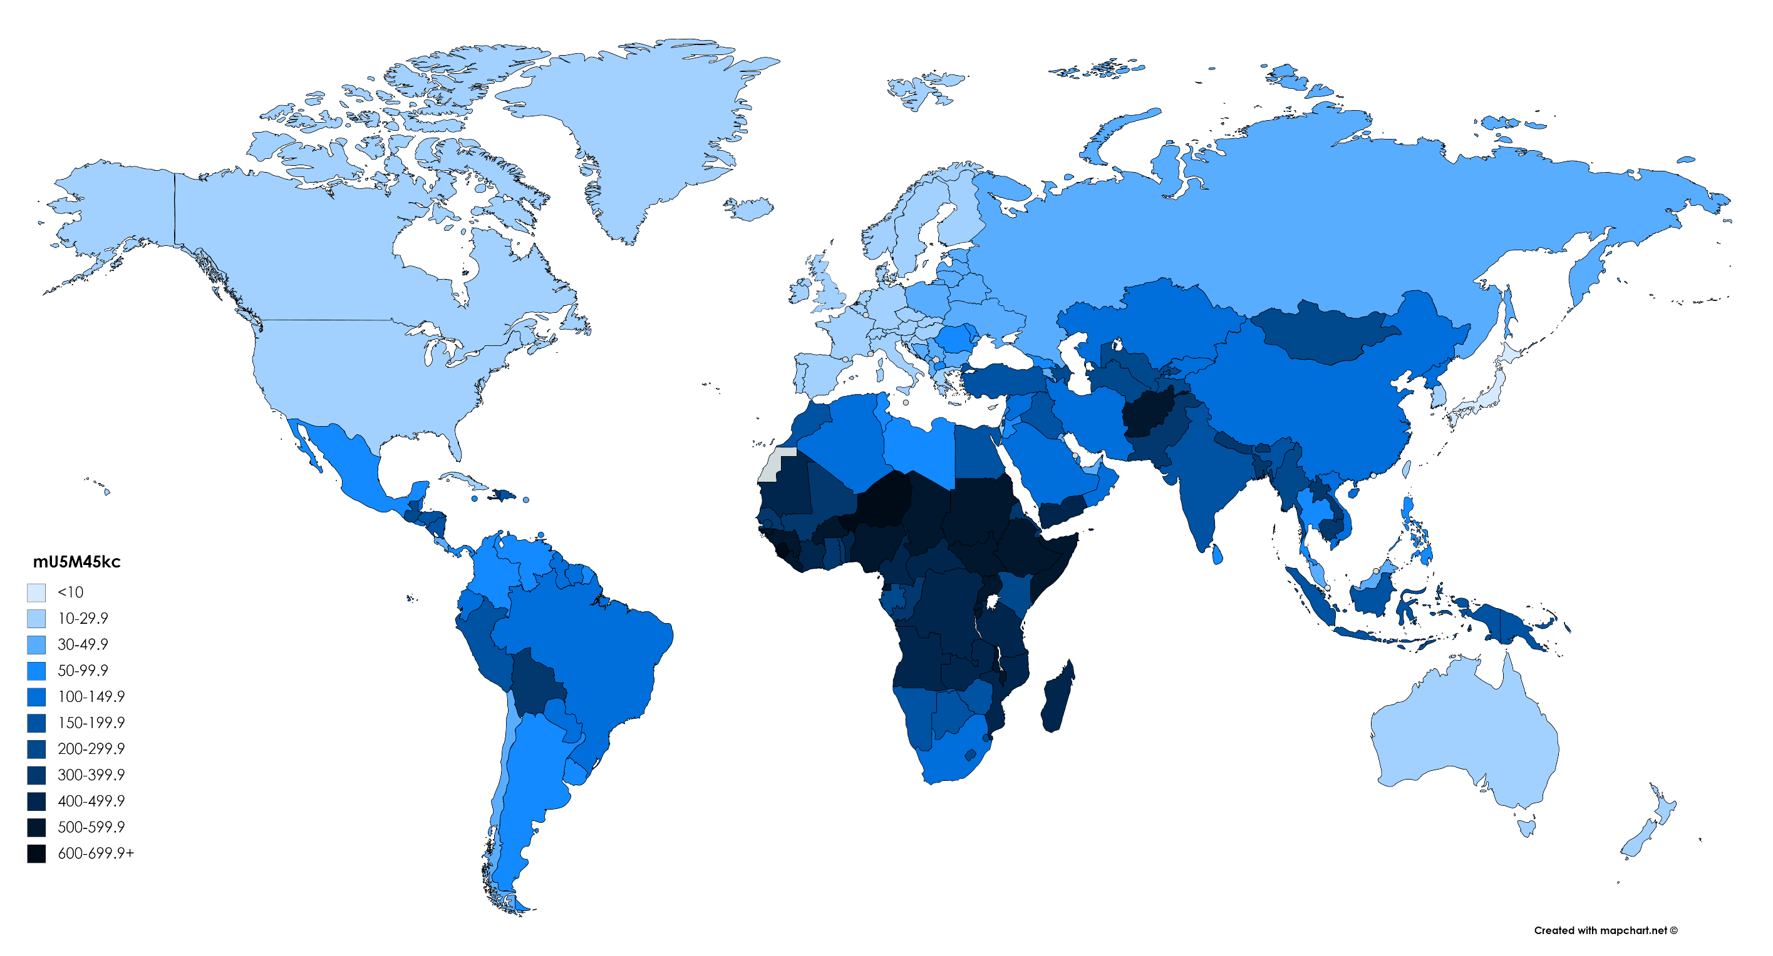

Note: see SI Table 1 for list of estimates and data sources

Fig. 5. Maternal Offspring Mortality (mOM) Indicators for mothers ages 45-49-years-old

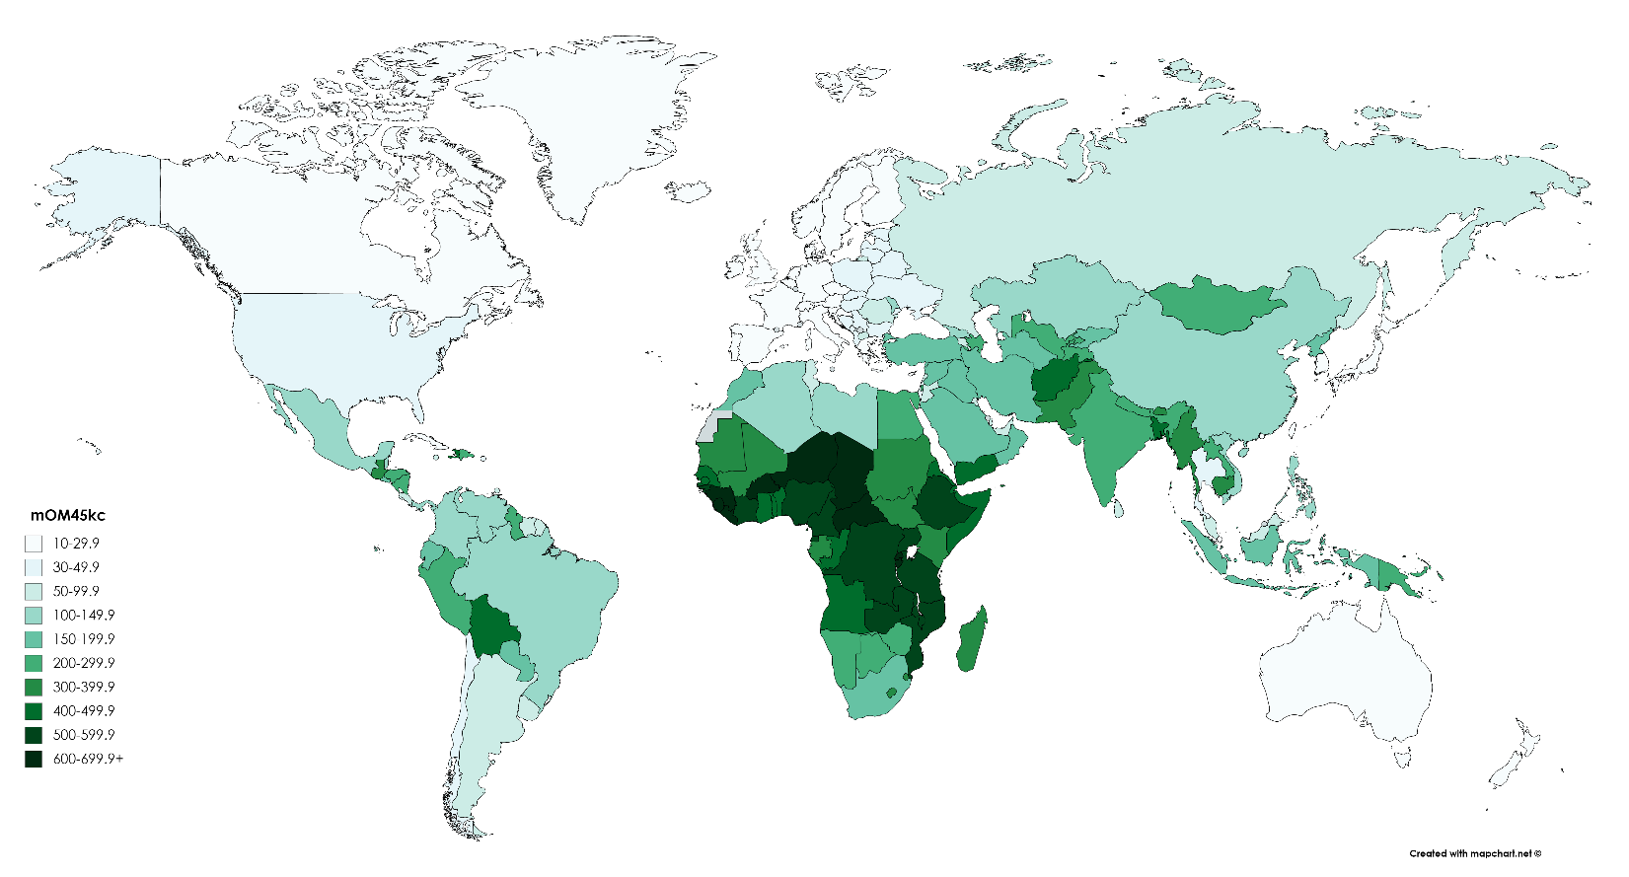

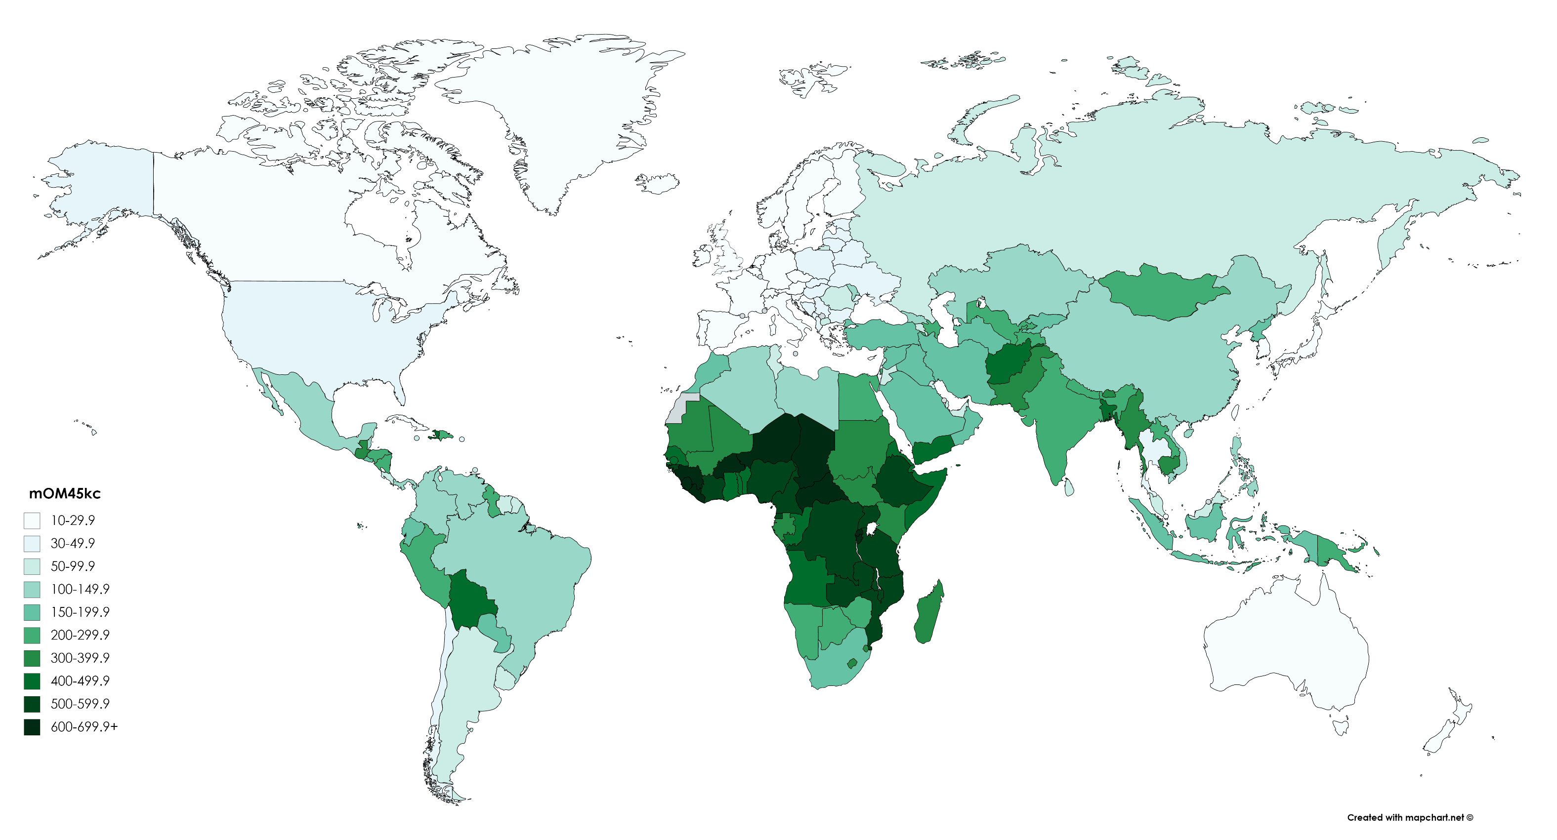

Note: see SI Table 1 for list of estimates and data sources

1. The public use surveys are available at <https://www.cdc.gov/nchs/nsfg/index.htm>. Because the NSFG included women 45 years and older in only one survey round, and because of the small sample for this age group, we rely on the indirect estimates of the mIM, mU5M, and mOM for older mothers.
2. These public use surveys, funded by the United States Agency for International Development (USAID) are publicly available at <https://dhsprogram.com/>.
3. These data are funded by the United Nations Children’s Fund (UNICEF) and are publicly available at <https://mics.unicef.org/>).
4. Given data constraints, we cannot include women bereaved by the loss of a fetus or a stillbirth.
5. More than 95% of women in our survey estimates had their first child at age 14 or older; because our oldest respondents are 49 years old, children on which women were reporting could be no more than 35 years old. Thus, these estimates pertain to children who died between infancy and young adulthood.
6. UNWPP data are publicly available at: <https://population.un.org/wpp/>. In select countries, mostly in Africa, UNWPP relies on model life tables given the lack of vital statistics. Fortunately, our survey coverage is exceptionally high in sub-Saharan Africa.